3 TIER ARCHITECT

IN THIS I HAVE TO CONNECT TO THE VPC

VPC IS VIRTUAL PRIVATE NETWORK IT IS ISOLATED NETWORK WHERE WE CAN CREATE MANY VPC INSIDE A DIFFERENT REGION OR A PARTICULAR REGION IN THE AWS ACCOUNT.

VPC : 10.0.0.0./24

SUBNETS BELONGS TO THE AVAILABILITY ZONES SUBNET IT IS RANGE OF IP ADDRESS INSIDE THE VPC

TO CALCULATE CIDR FOR CREATING THE CUSTOM VPC AND SUBNET

2^32-X =N

X IS THE NUMBER AFTER THE / IN VPC

2^32-24=8 2^8 = 256 THE PARTICULAR VPC RANGES UPTO 256 I P Address

N = NO OF IP ADDRESS WE CAN CREATE

2^32-X= N

2^32 = 2^5

2^32-5 = 27

27 is the number after the / in the subnet it will remain constant

256/8 = 32

32 is the number before /

10.0.0.0/27.- public web server 1

10.0.0.224/27

10.0.0.32/27- public web server2

10.0.0.64/27- public web server 3

10.0.0.96/27- private app server 1

10.0.0.128/27 – private app server 2

10.0.0.160/27- private db server 1

10.0.0.192/27- private db server 2

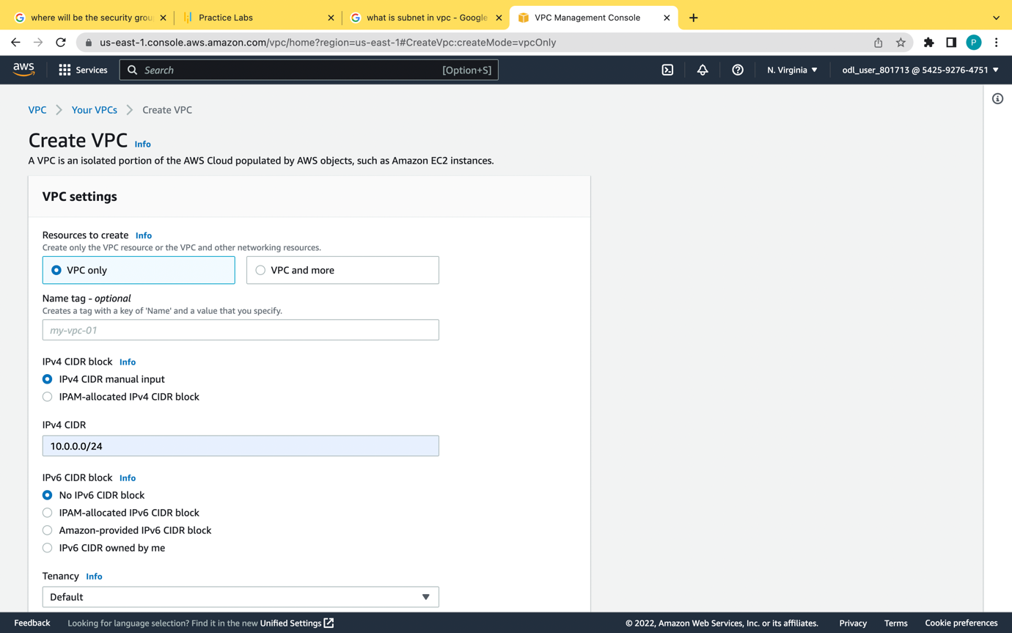

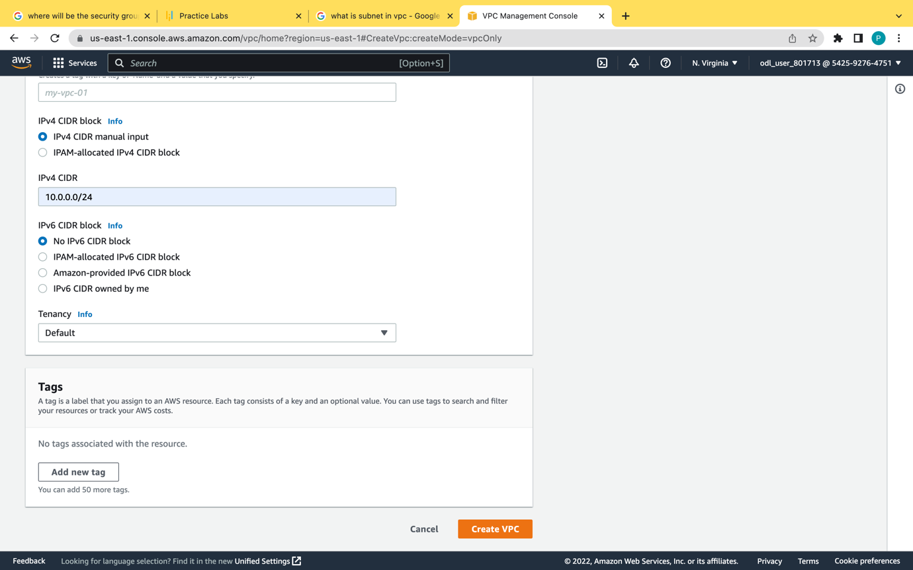

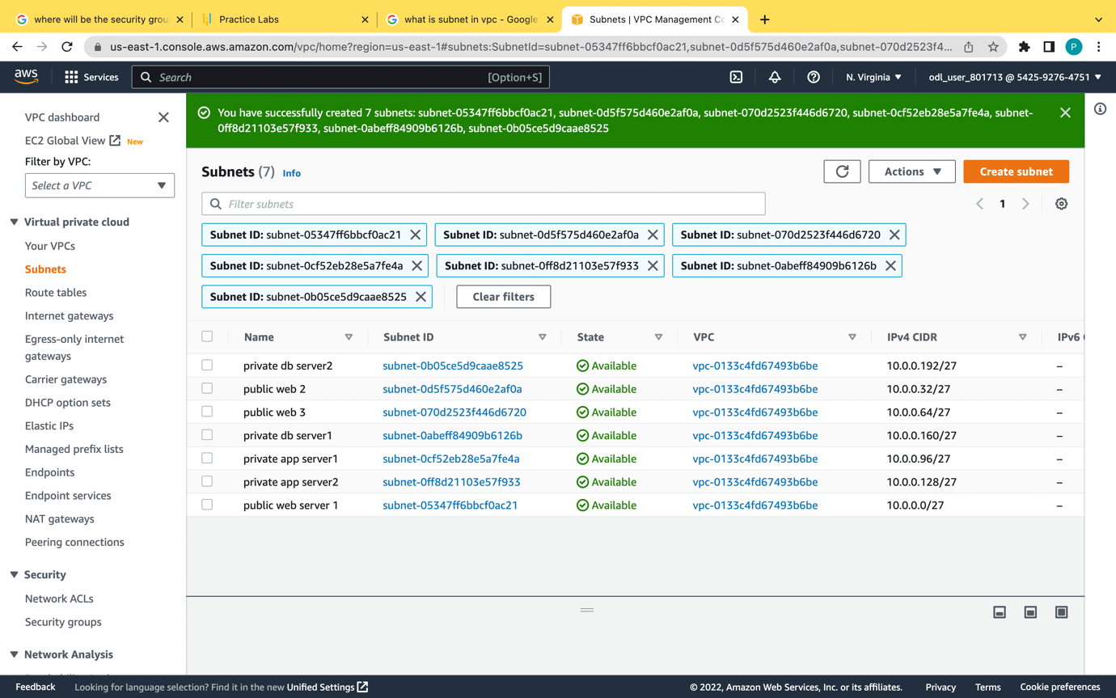

Route table

It describes the set of rules and network traffic between vpc and subnet

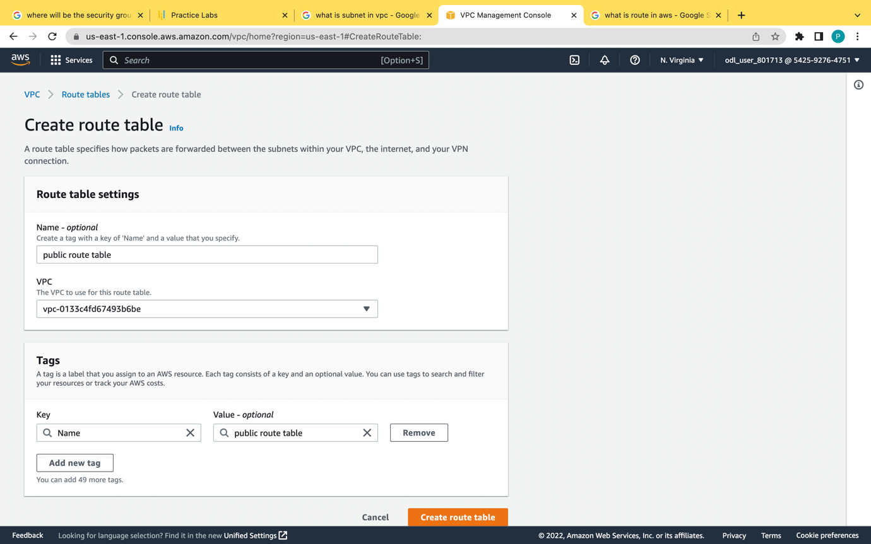

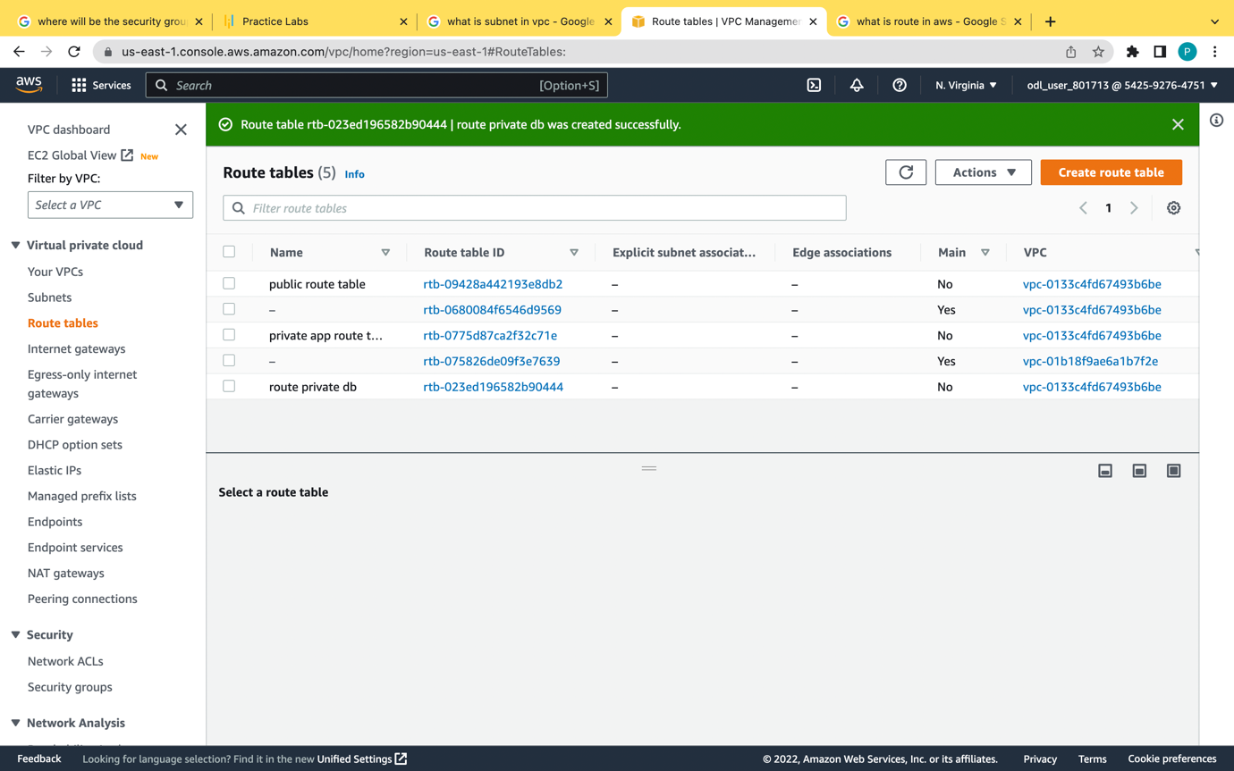

I have created the route table in public web server

Private app

Private dbms server

Edit route association 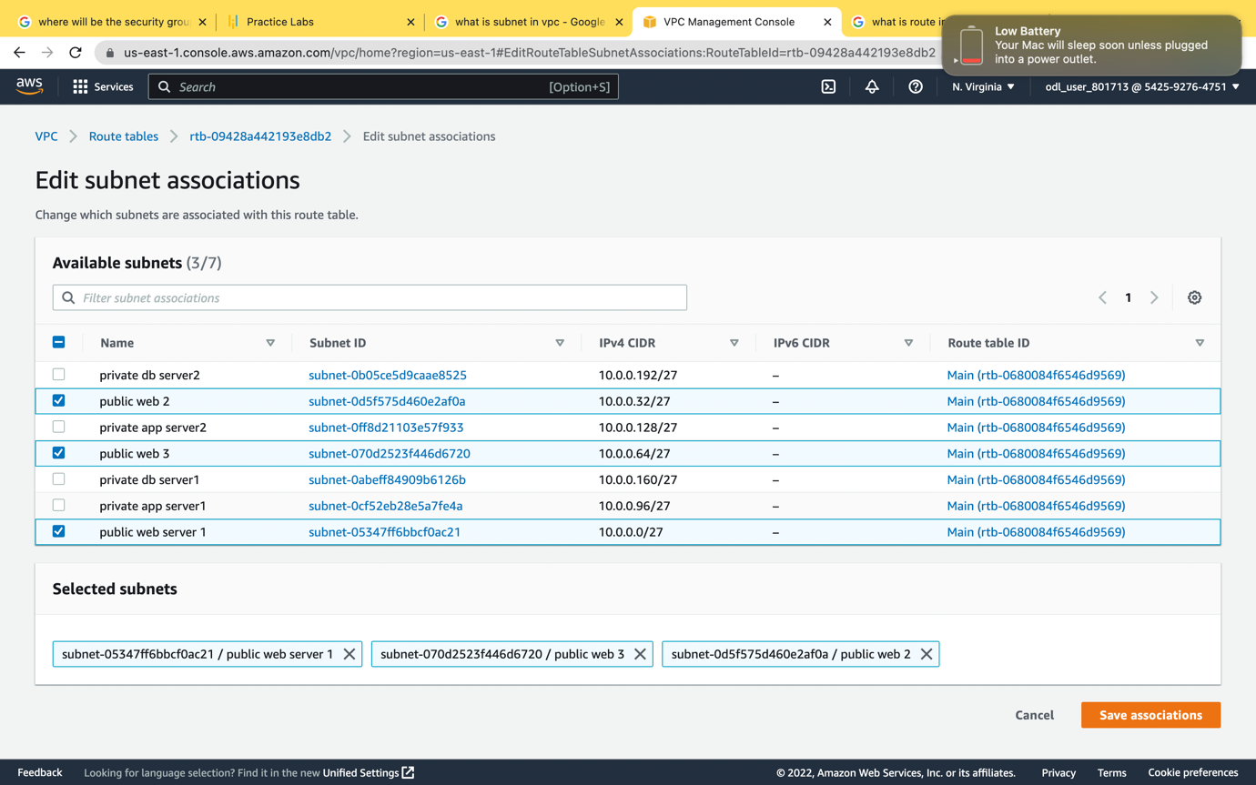

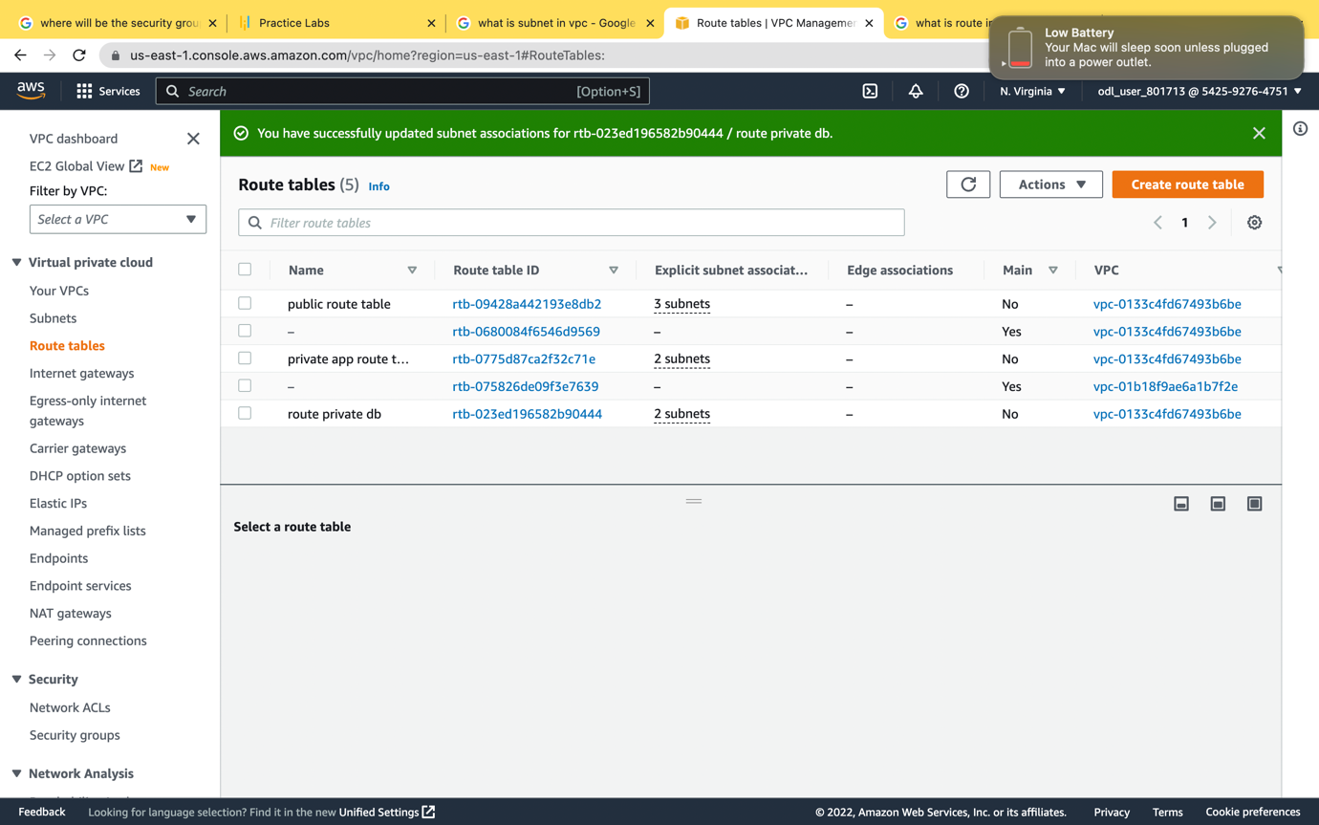

I have created three edit route association one is public route table another is private app server and private dbs

create internet gateway for the public web server and attach to the vpc

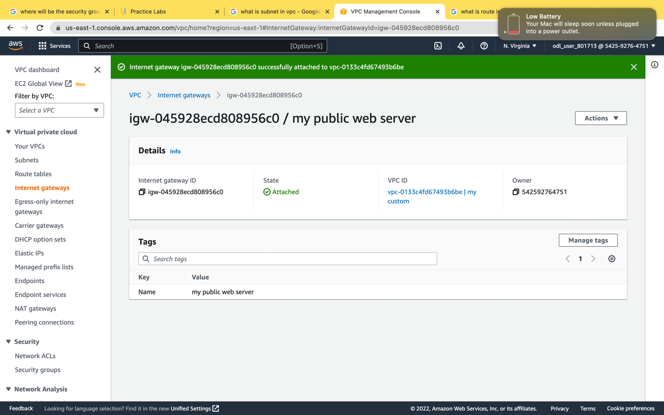

For private app server

and database server we should create a NAT GATEWAY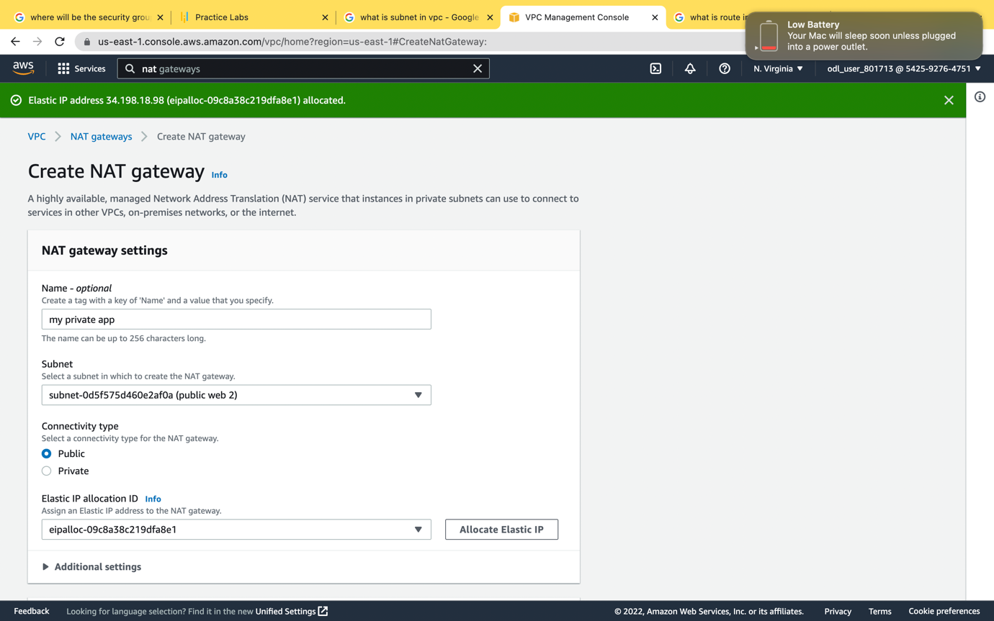

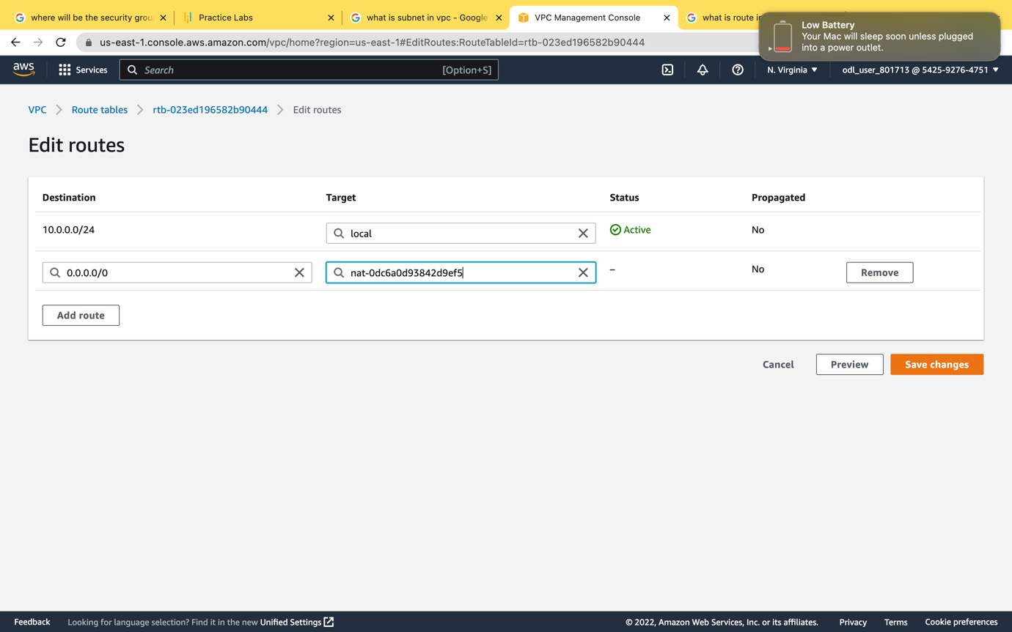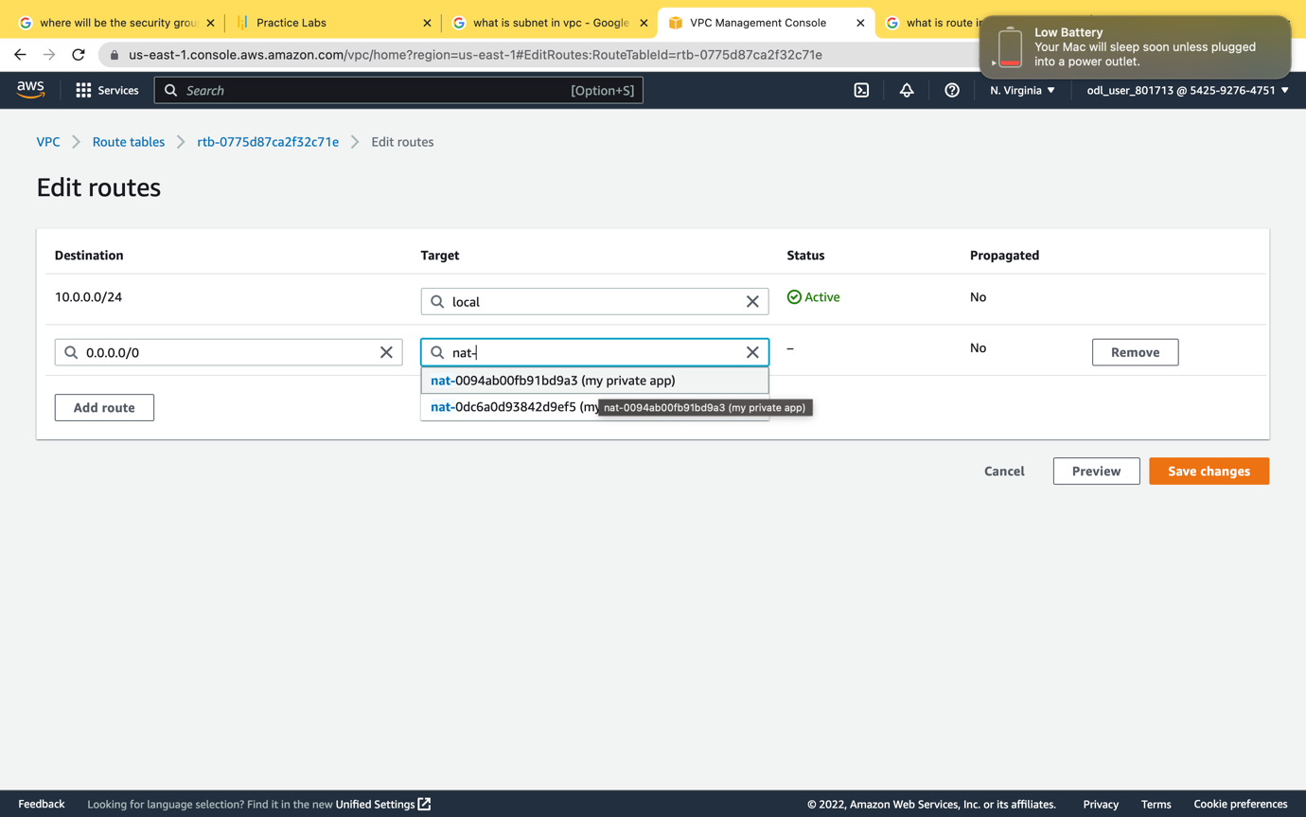in this I have added the private nat gateway of app server



Create ec2 instances one for jump server other for app service we have created two app servers for high availablility

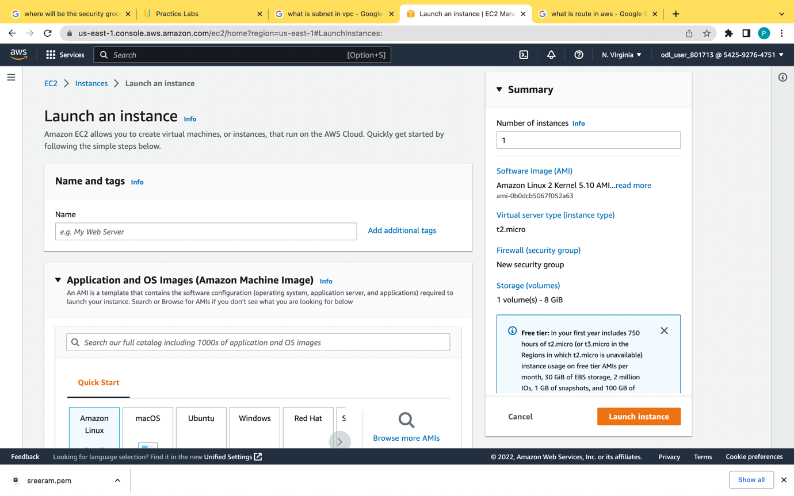

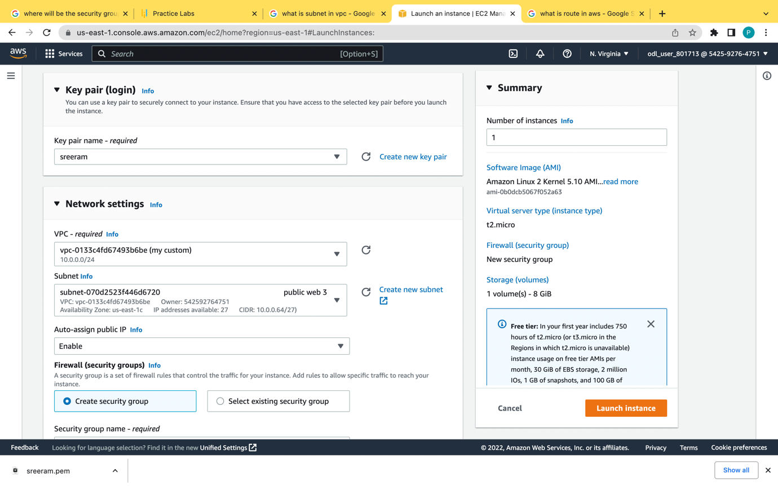

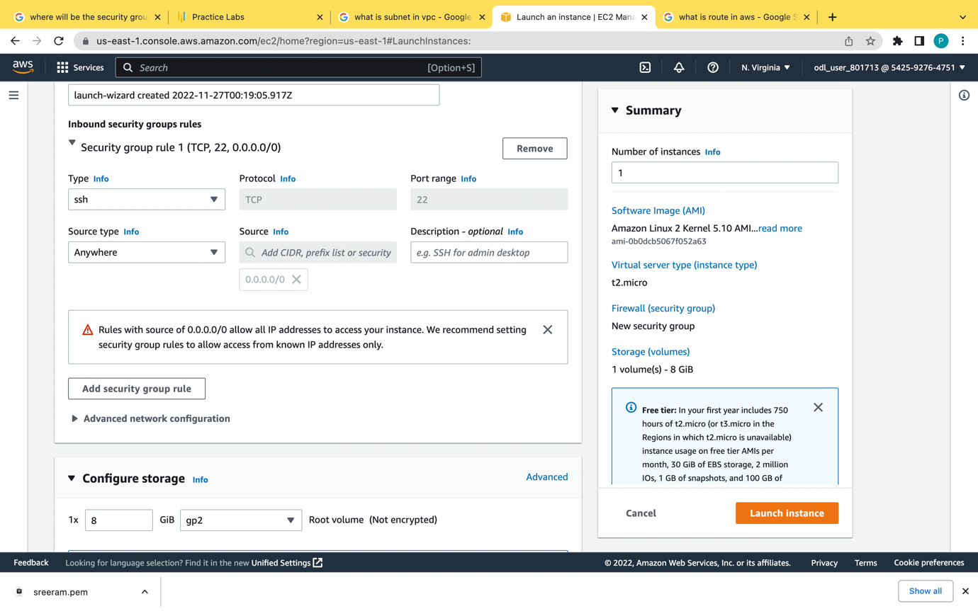

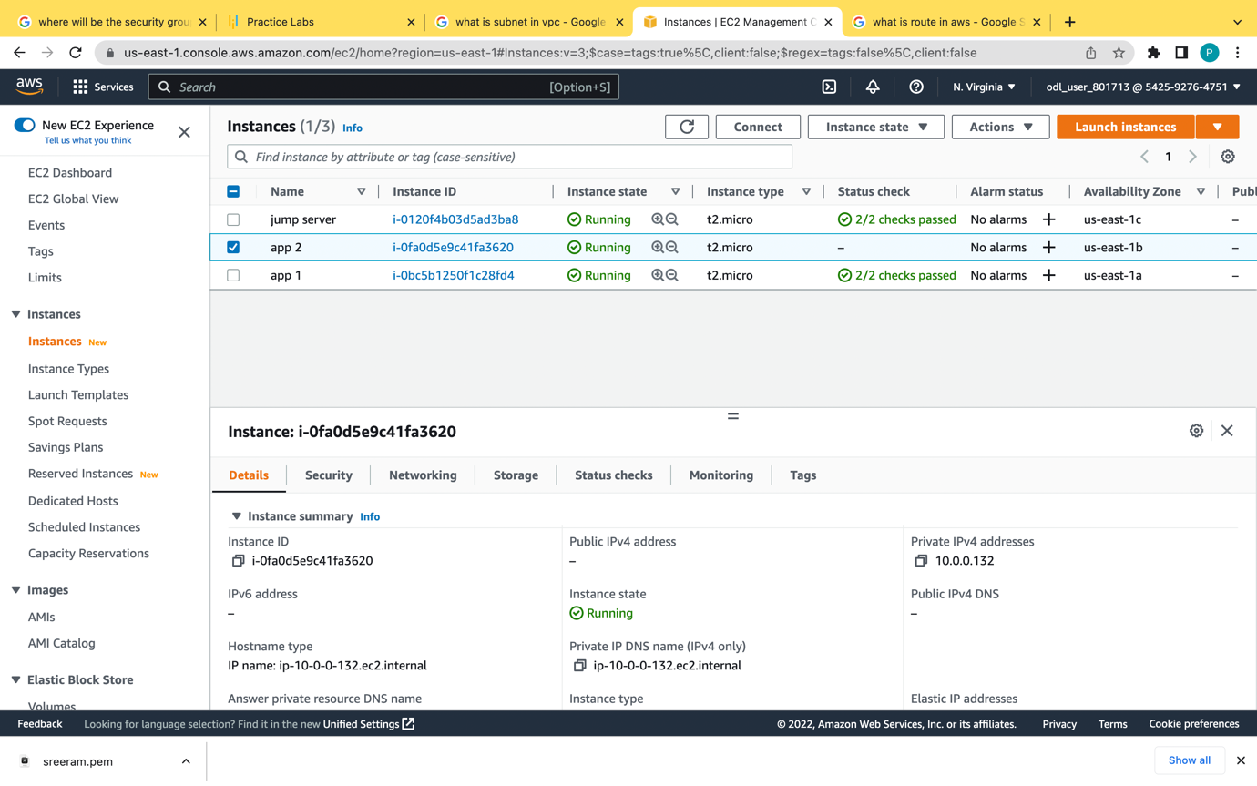

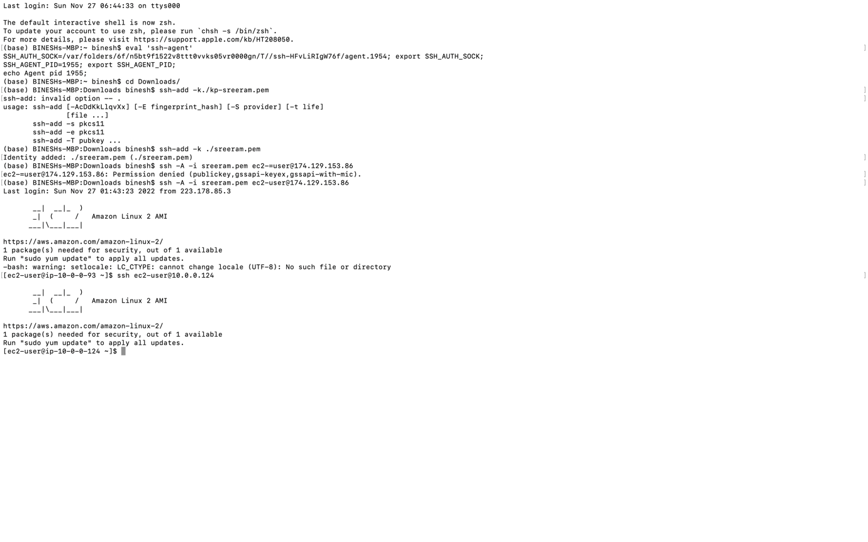

By using ssh forwarding we can do the public jumb is able toconnected to the app server.

Eval ‘ssh-agent’

Cd downloads/

Ssh-add -k ./file name

Chmod 400 file name

Ssh-add -k ./file name

Ssh -A -i key name ec2-user@pub ip address

Ssh ec2-user@private ip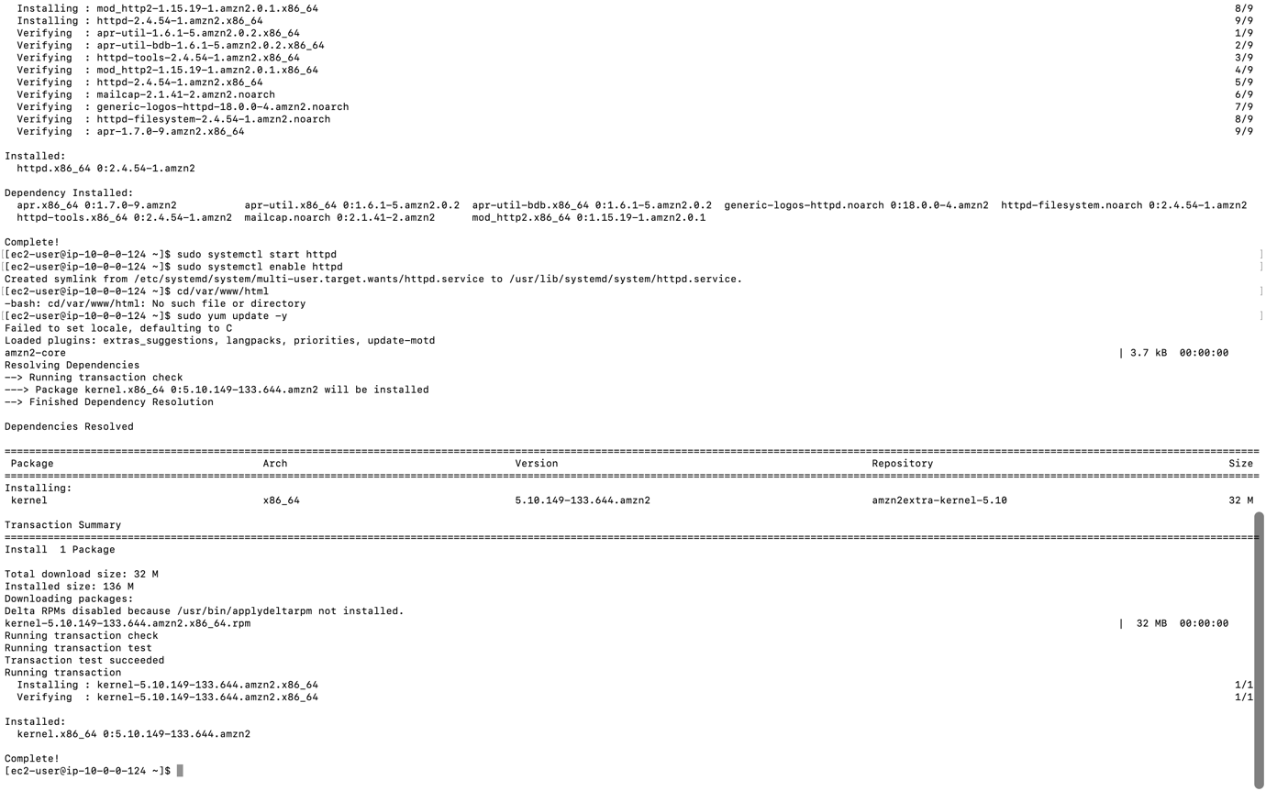

We are installing all the packages in private app server for the apache and php

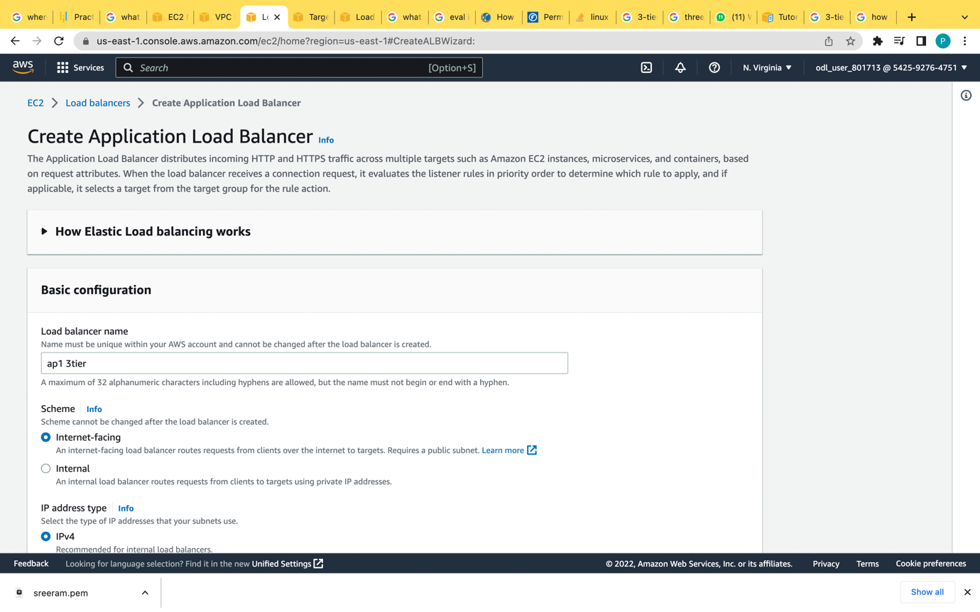

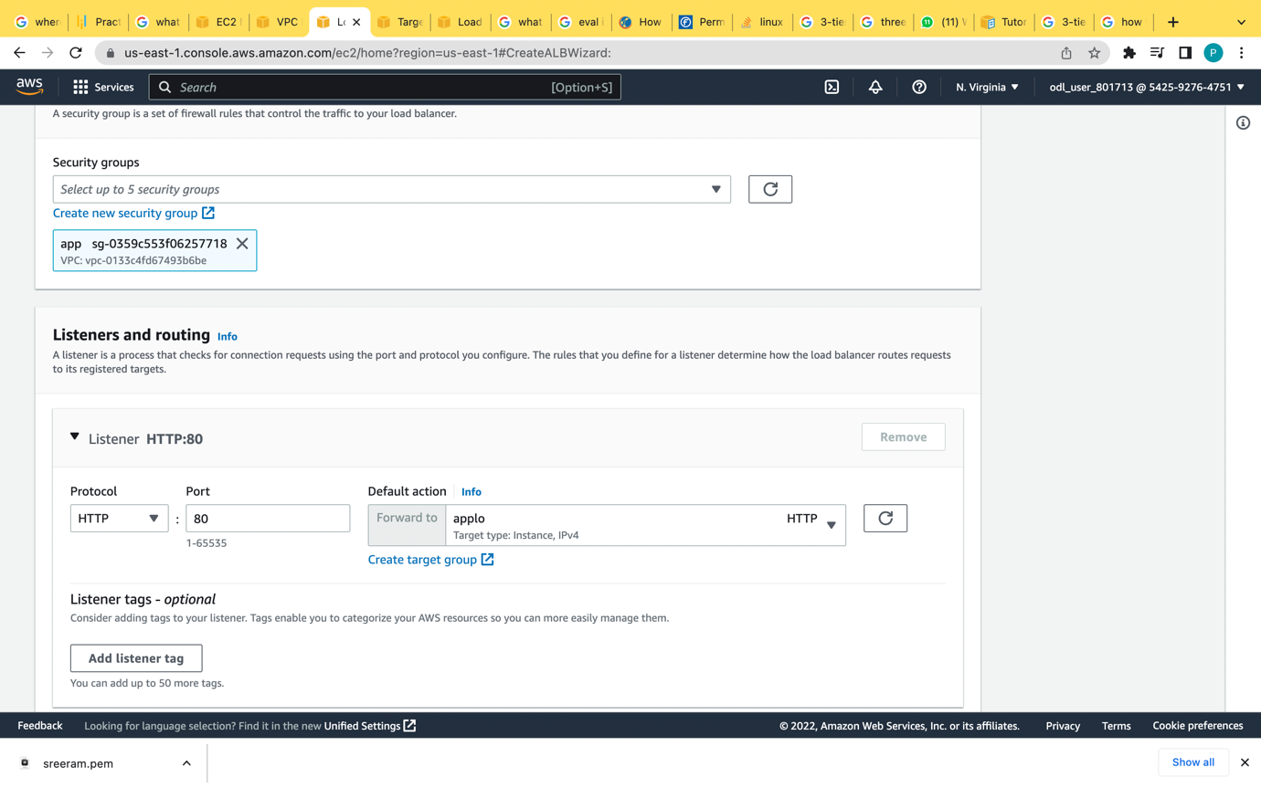

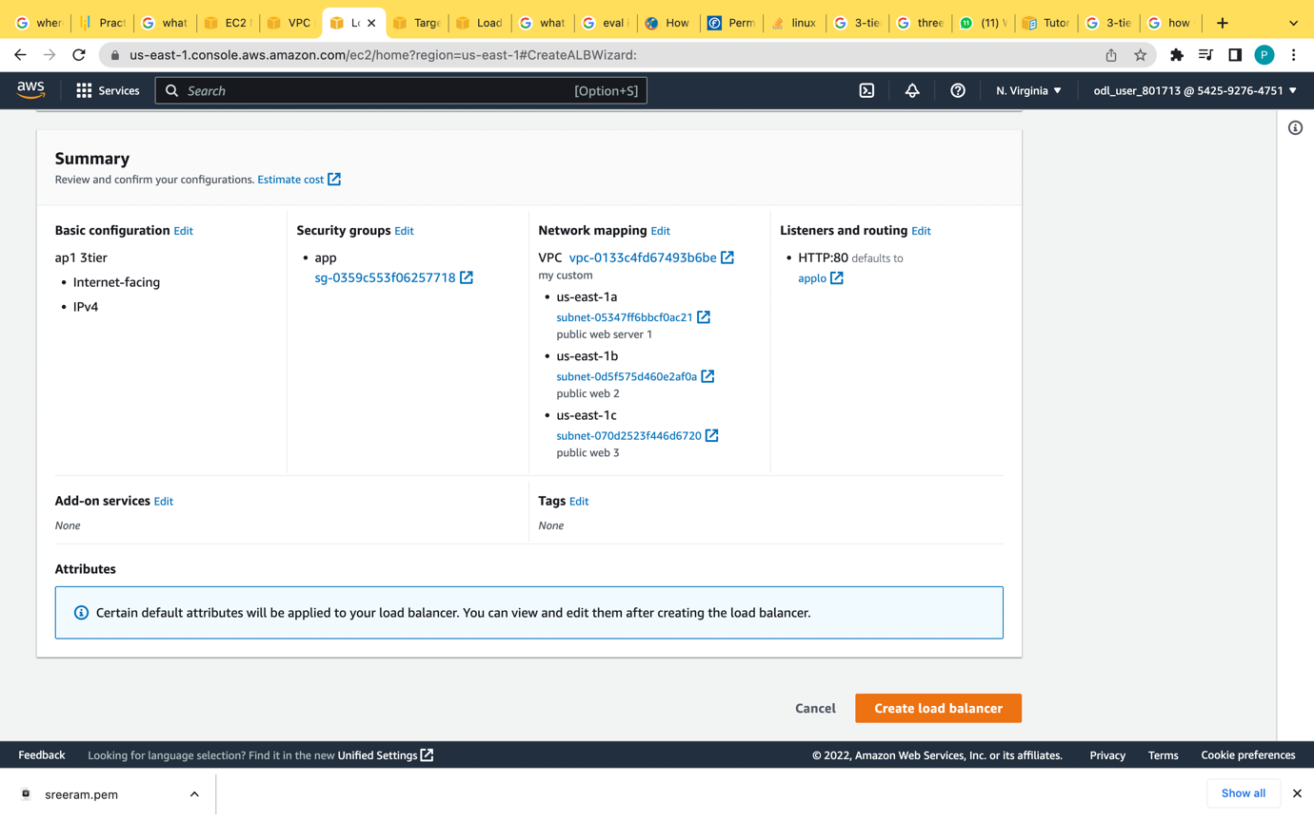

I have created a application load balancer to check whether the application is working

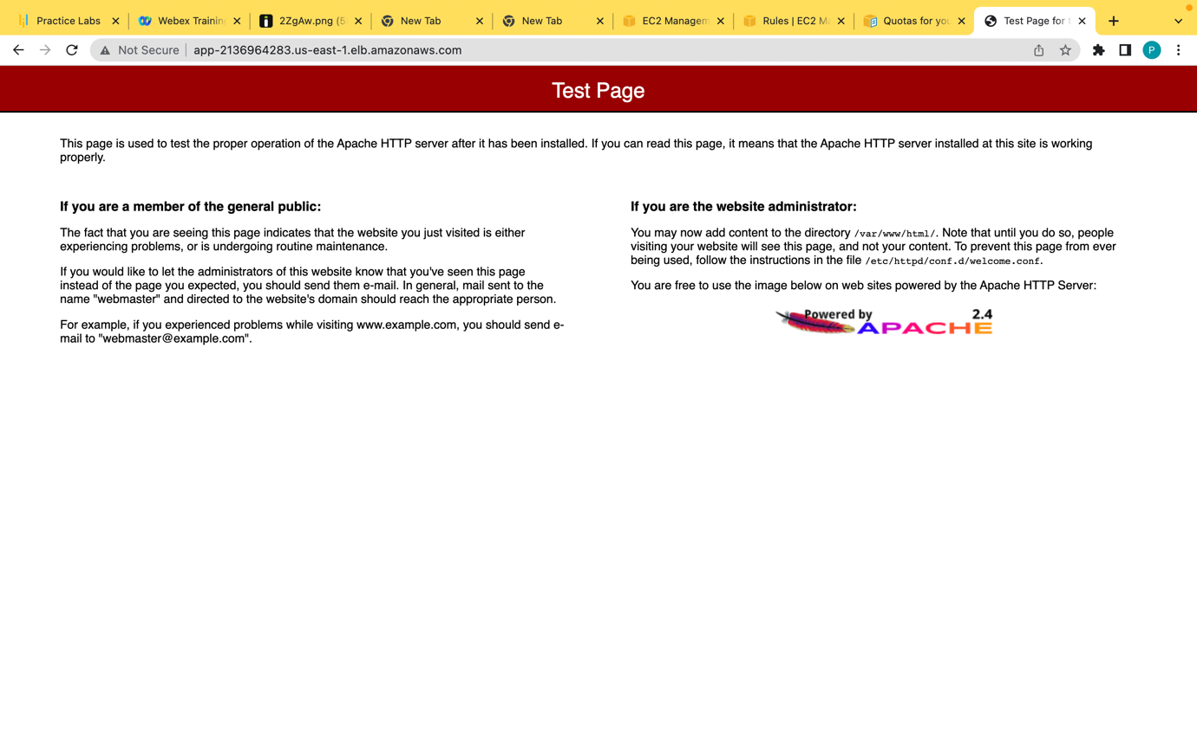the application is working properly

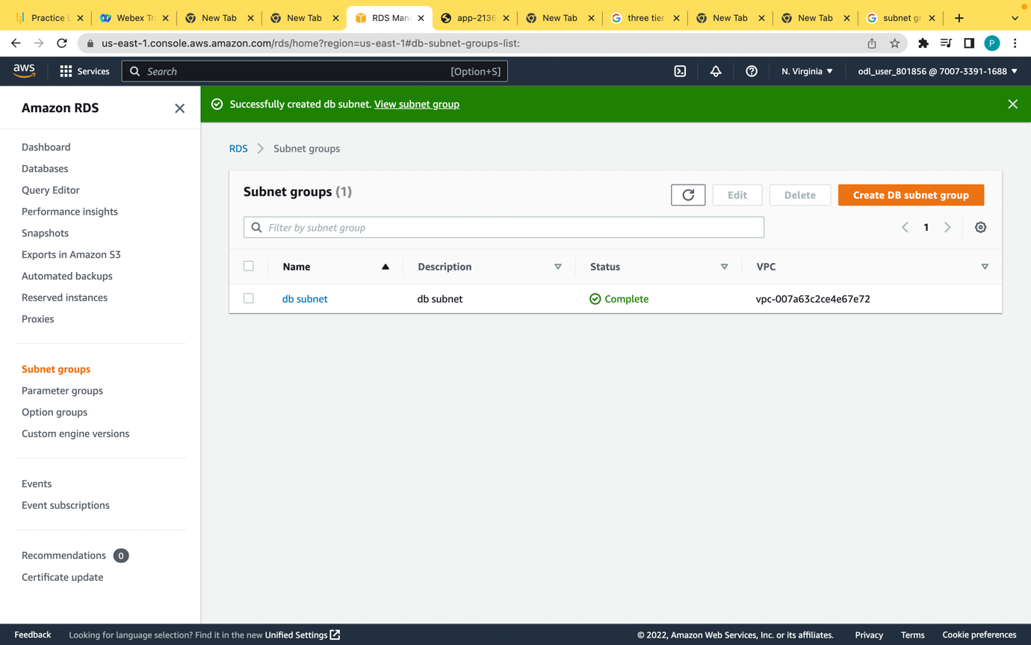 for the rdms create the subnet group the db should be present in two availability zones.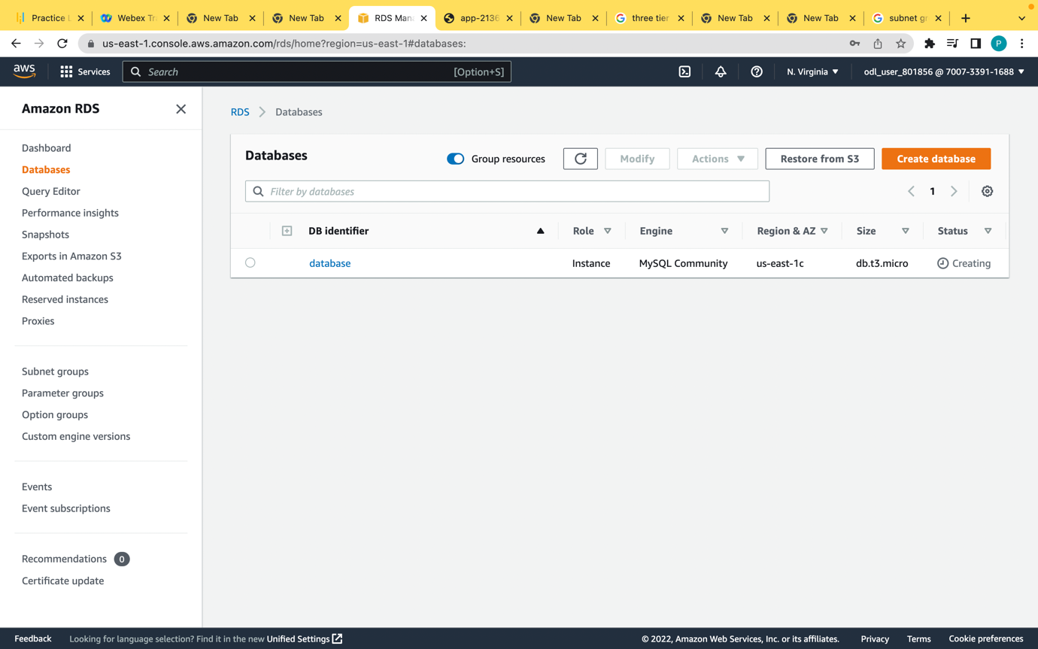

Create the mysql database for the database application

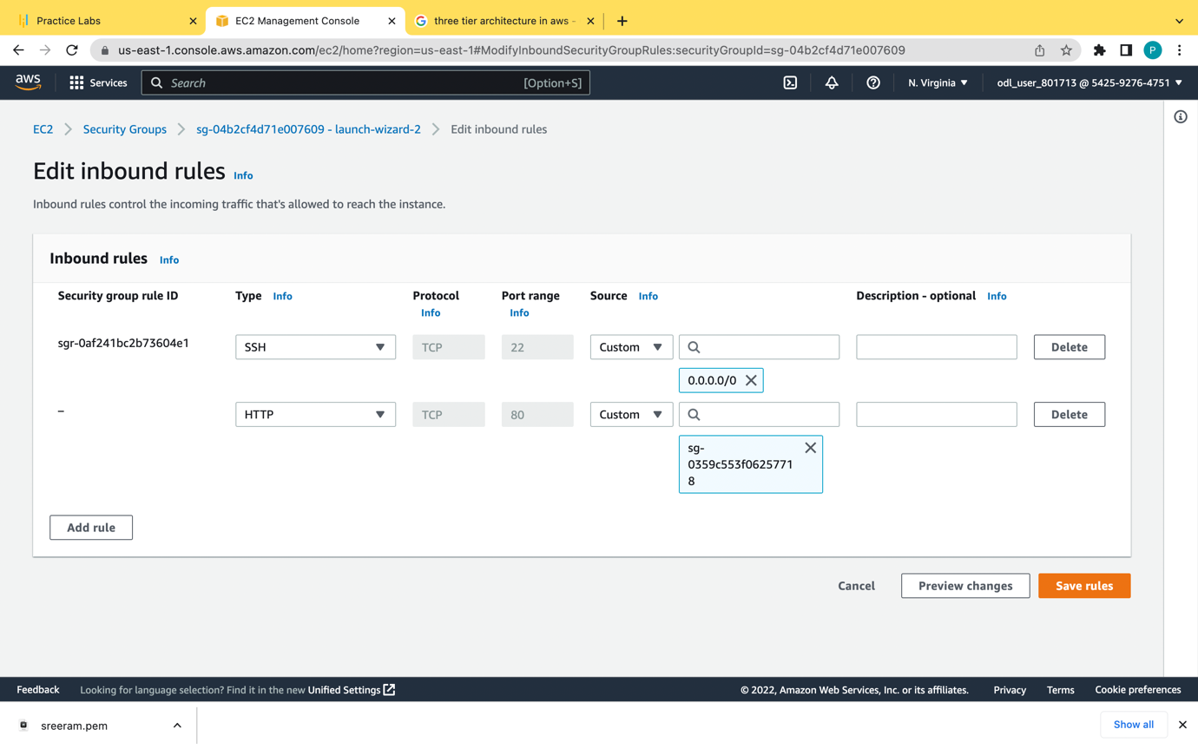

We have add the security group of database in app server ec2

